
Tertiary Infotech Academy Pte Ltd
UEN: 201200696W
PRACTICAL PERFORMANCE ASSESSMENT
For
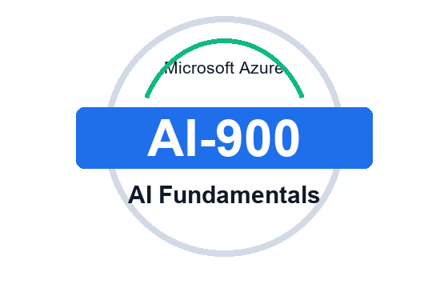
Microsoft Azure AI Fundamentals (AI-900)
TGS Ref No: TGS-2023021100
Conducted by
Tertiary Infotech Academy Pte Ltd
UEN: 201200696W
Version v1

Practical Performance Assessment
Microsoft Azure AI Fundamentals (AI-900) - TGS-2023021100 - v1

A. Trainee Information
Trainee Name
Last 3 NRIC Digits + Alphabet
Assessment Date
Assessor Name

B. Instructions to Candidate
- Complete all 5 practical tasks.
- The practical performance must follow the AI-900 labs completed in class.
- Use screenshots, completed tables, notes or output evidence from the labs.
- Do not submit personal or confidential data.

C. Scenario
A retail and service organisation wants to introduce Azure AI capabilities across customer support, document processing, product quality review, multilingual communication, analytics and internal knowledge workflows. Complete the practical tasks below by following the sequence and evidence produced in the AI-900 labs.

D. Practical Tasks

Task 1 (LO1) - Labs 01 and 10
Classify AI workloads, map them to Azure AI services and create a responsible AI checklist for the organisation's scenario.
Show your completed workload-service-control mapping and responsible AI checklist in the box below.

Task 2 (LO2) - Labs 02 and 03
Prepare a machine learning solution outline that identifies the ML technique, features, labels, lifecycle stages and Azure Machine Learning evidence.
Show your ML technique table, lifecycle notes and Azure Machine Learning validation evidence in the box below.

Task 3 (LO3) - Labs 04, 05, 06 and 07
Complete an Azure AI services evidence pack for vision, language, speech/translation and document intelligence or search.
Show screenshots or notes proving each service output and validation check in the box below.

Task 4 (LO4) - Lab 08
Use generative AI concepts to design a safe Azure AI Foundry or Azure OpenAI interaction for a business support scenario.
Show your prompt, expected output, grounding/review notes and safety controls in the box below.

Task 5 (LO5) - Labs 09 and 10
Produce a final Azure AI solution design that includes service selection, governance, security, cost controls, validation and cleanup.
Show your final design map, control checklist, validation evidence and cleanup plan in the box below.

For Official Use Only
Assessment Result | Competent / Not Yet Competent
Assessor Name
Assessor NRIC
Date
Signature

